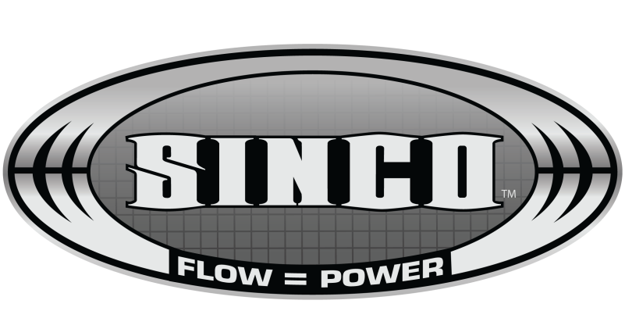
Fitment Guide – Vr4 T3 or Vband

This is a general guide to help you fit our SINCO turbo manifold - This will only suit our 4g63 Vr4 T3 or Vband manifold other brands will be different. These are some helpful hints that we have learnt along the way that will help save time and elimante error.

There are x3 main factors that you will have to work around to fit this manifold correctly. These are the distance between the rear of the turbo and the oil filter when fabricating your downpipe. The distance between the compressor outlet of the turbo and the crossmember and finally the lack of room for the extrnal waste-gate pipe.

1: Downpipe Fabrication

For the turbo compressor cover to clear the engine mount that is bolted to the block (on the evo1-3 these are bolted to the gearbox so they have a lot more room) the turbo is limited to how far away it sits from the alternator and the oil filter. This causes the downpipe to be very tight if you still want enough clearance to be able to undo and replace the oil filter without having to pull off the downpipe each time then there are x2 ways to achieve this.

- One way is to use a tight raduis donut to fabricate the section the runs off the downpipe. The donut alone is not quite tight enough so you will have to backcut the donut to a tighter angle.

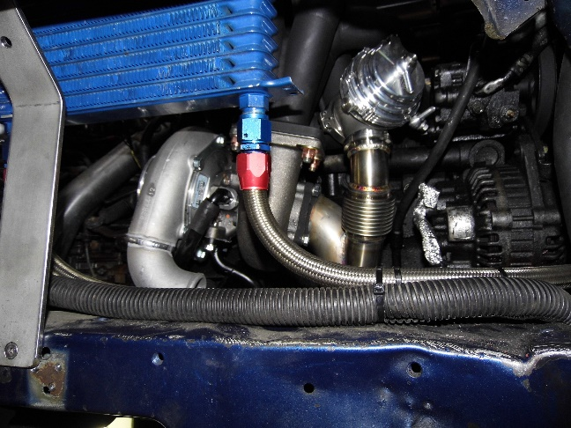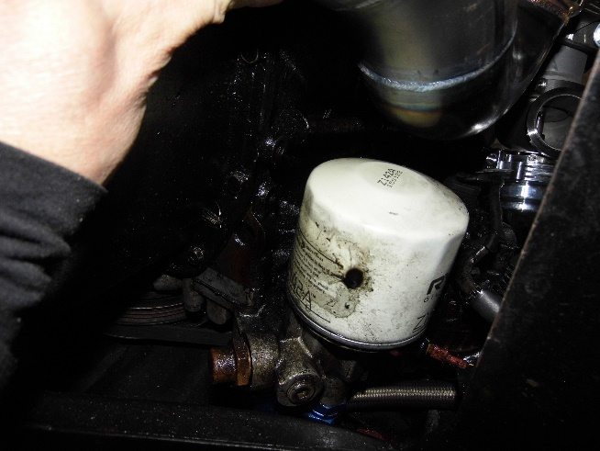

You can see in these pictures above that the elbow/donut off the downpipe has been backcut, this moves it away from the alternator and gives better clearance for the oil filter

2: Downpipe Fabrication

- The other way and best way to give the most clearance is to run a remote oil filter relocator like pictured below, this will allow for no backcut on the donut that runs off the back of the turbo.

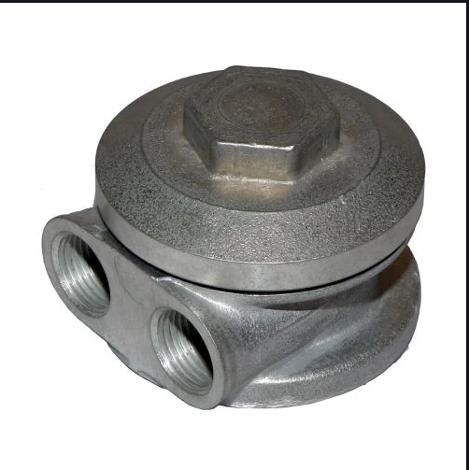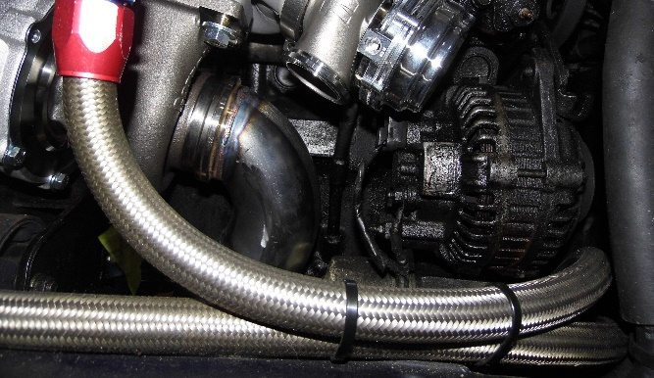

Turbo Compressor Clearance

- For the intercooler pipe to clear the front crossmember you will need to cut and weld a 2” cast elbow or a 2” tight raduis alloy donut that is cut to 90 degrees. In the pictures below it shows how much the elbow needs to be cut back.

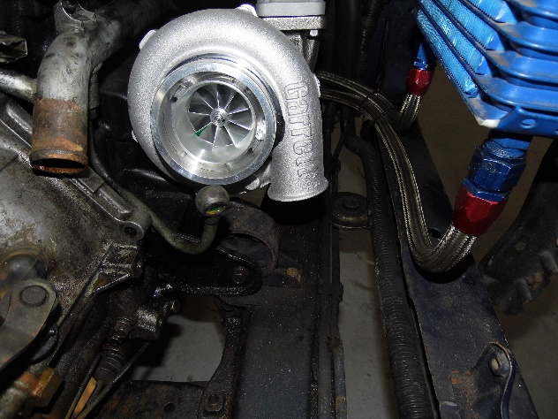
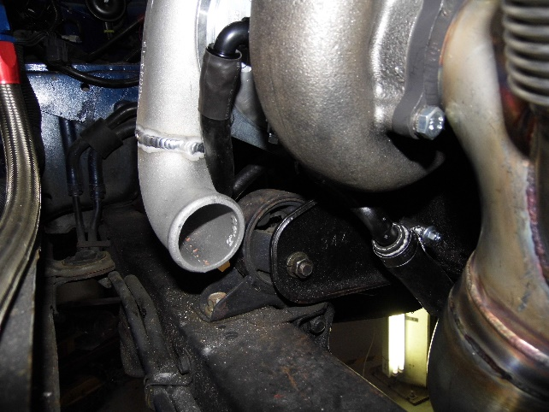

External Wastegate Pipe

As pictured below the external wastegate pipe will need to run stright back into the exhaust up by the top of the donut that runs off the back of the turbo. There is limited room for a screamer pipe as the intercooler pipe needs to run along the crossmember.

